**Quiz/Test/Exam Instructions**

All tests **must** be completed in a Windows operating system using a recent version of Excel. Before the test, create a folder on your desktop for the test file(s) and use this folder during the test. Be sure you know how to locate downloaded and saved files. You must start the test on time as late starts may be penalized. **Before the test starts:**

* Create a folder on your desktop named “FIN 4331” and make it and subfolders a Trusted Location to ensure that the macro enabled test workbook can be opened. Inside the FIN 4331 folder create a folder named “Test”.
* Check your computer date and time to make sure that it is correct so that the time stamp on your test file and email will show that it was completed on time.
* **Turn off OneDrive.** In the Task Bar, left click the OneDrive blue cloud. Select the Settings (Gear button at top right of window) and then Quit OneDrive.
* Close all applications not required during the test.

The test starts when the instructor gives you the location and password of the test workbook:

* Download the test workbook as instructed and drag it to the **“Test”** folder on your desktop. KEEP ALL TEST FILES IN THIS FOLDER!
* **Disable wireless.**
* Open the test workbook in Excel by left double clicking on the file name in Windows Explorer, then enter the password. When the file opens, Enable Editing and Enable Content if prompted.
* If prompted, enter your 3-digit class number. Note that this is NOT your section number.
* In Excel, use *File Save As* to rename the file with your 3-digit class number followed by last name (ex. 005Adams). The workbook macro will flash a message to “… Close then Reopen the workbook to continue!”. Click OK. Excel will show the Save As screen. Change the file name, be sure the location is the Test folder on your desktop, and then click Save. During the test you may rename the test file as often as you like, saving it in the test folder with the others.
* The question sheets on your workbook are now hidden. Close then reopen your workbook. Enter the password, Enable Editing and Enable Content if prompted, and then your class # as before to unhide the question sheets.
* When you have completed the test workbook, save it and close Excel. Email it as directed. **Be very careful to attach the correct file to your email!**
* Verify that your email was sent before you shut down your laptop or lose internet connection.
* **Delete the test folder contents and then all related files in the Trash, Downloads, email, and test folders. There should be no test files on your computer now.**

Be aware that during the test a macro may record your keystrokes and command sequences.

If you are authorized to receive additional time due to a disability, ignore any late message, continue working on the exam, then email as instructed when your extended time is up.

During the test you may access only applications or programs required to do the test. **Do not open documents or files other than the exam workbook.** Do not open or display browser tabs other than those required to do the test. Access to written materials or devices other than your testing computer is not allowed, including cell phones, calculators, iPads, tablets, notes, scratch paper, etc. When you are working on the test save the Excel file every few minutes. The macro running in the background will be recording actions you take as you work on the spreadsheet. *Unless otherwise instructed*:

* + **Don’t move cell contents to another location.**
  + **Don’t move, copy, rename, insert, or delete workbook sheets.**
  + **Don’t insert, move, or delete rows or columns.**
  + **Don’t protect or unprotect cells, sheets, or workbooks.**
  + **Don’t open any workbook other than the test workbook(s).**
  + **Don’t change or add VBA code.**
  + **Don’t access Excel Help (F1) as it may open a new browser tab.**

Performing any of the above may render your workbook ungradable or result in a zero on the test.

***Excel Trusted Locations.docx:***

**Prior to the exam be sure to create a folder on your desktop named “FIN 4331” then make it a Trusted Location to ensure that the macro enabled test workbook can be opened.**

1. **Create a test folder on your desktop.** These steps are important if using OneDrive.
   1. In Windows File Explorer right-click your computer’s hard drive - Local Disk C:
   2. Select *New* then select *Folder*
   3. Rename folder “FIN 4331”
   4. Drag this folder to the desktop
2. **Next, set up a trusted location:**
3. In Excel, on the Developer tab, select the Macro Security button. This activates the Trust Center dialog box (see below).
4. On the left, click Trusted Locations. The Trusted Locations menu appears, displaying all the directories that are considered trusted.

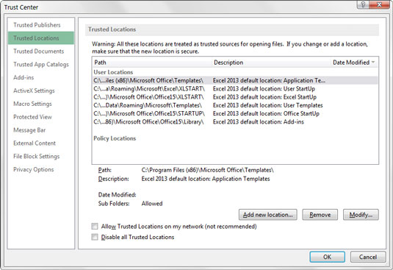

1. Add directories that are considered trusted: Click the *Add New Location* button.
2. Click *Browse* then find and select a directory that will be considered a trusted location, including: “FIN 4331”. Check the Subfolders box to include all subfolders.