Prior to the exam be sure to create a folder on your PC named: “C:\FIN 4331” then make it a Trusted Location to ensure that the macro enabled test workbook can be opened. Be sure to select “Sub Folders allowed”.
- Create a test folder on your PC. These steps are important if using OneDrive.
  - In Windows File Explorer right-click your computer’s hard drive – normally Local Disk C:
  - Select New then select Folder
  - Rename folder “FIN 4331”
  - Open the FIN 4331 folder and create a “Test” folder inside it

- Next, set up a trusted location:
- In Excel, on the Developer tab, select the Macro Security button. This activates the Trust Center dialog box (see below).
- On the left, click Trusted Locations. The Trusted Locations menu appears, displaying all the directories that are considered trusted.
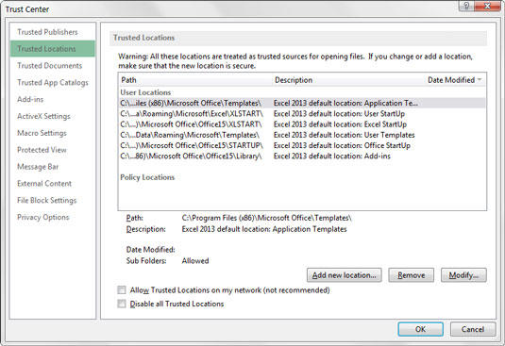
- Add directories that are considered trusted: Click the Add New Location button.
- Click Browse then find and select a directory that will be considered a trusted location, including: “C:\FIN 4331\Test”. After downloading the test workbook drag it to this location.

