**Prior to the exam be sure to create a folder on your PC named**: “**C:\FIN 4331**” **then make it a Trusted Location to ensure that the macro enabled test workbook can be opened. Be sure to select “Sub Folders allowed”.**

1. **Create a test folder on your PC.** These steps are important if using OneDrive.
   1. In Windows File Explorer right-click your computer’s hard drive – normally Local Disk **C:**
   2. Select *New* then select *Folder*
   3. Rename folder “**FIN 4331**”
   4. Open the FIN 4331 folder and create a “**Test”** folder inside it
2. **Next, set up a trusted location:**
3. In Excel, on the Developer tab, select the Macro Security button. This activates the Trust Center dialog box (see below).
4. On the left, click Trusted Locations. The Trusted Locations menu appears, displaying all the directories that are considered trusted.

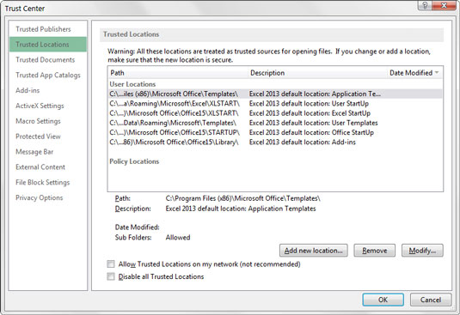

1. Add directories that are considered trusted: Click the *Add New Location* button.
2. Click *Browse* then find and select a directory that will be considered a trusted location, including: “**C:\FIN 4331\Test**”. After downloading the test workbook drag it to this location.