Finance is founded on six principles:

- Money has a time value. Cash is king.
- Higher returns are expected to take on more risk.
- Diversification of investments can reduce risk.
- Financial markets are efficient in pricing securities.
- Manager and stockholder objectives may differ.
- Reputation matters.
An individual’s reputation reflects their ethical behavior which is how an individual treats others legally, fairly, and honestly.

Assumptions of the Capital Asset Pricing Model (CAPM):

- Investors are Rational: All investors act rationally and seek to maximize their utility.
- Market Efficiency: Markets are efficient, meaning all available information is reflected in asset prices.
- Single Period Investment Horizon: Investors make decisions based on a single time period, typically one year.
- Risk-Free Rate: There exists a risk-free rate at which investors can lend or borrow money.
- Systematic Risk: Only systematic risk (market risk) is relevant; unsystematic risk can be diversified away.
- Homogeneous Expectations: All investors have the same expectations regarding future returns and risks of assets.

CAPITAL MARKET LINE (CML)

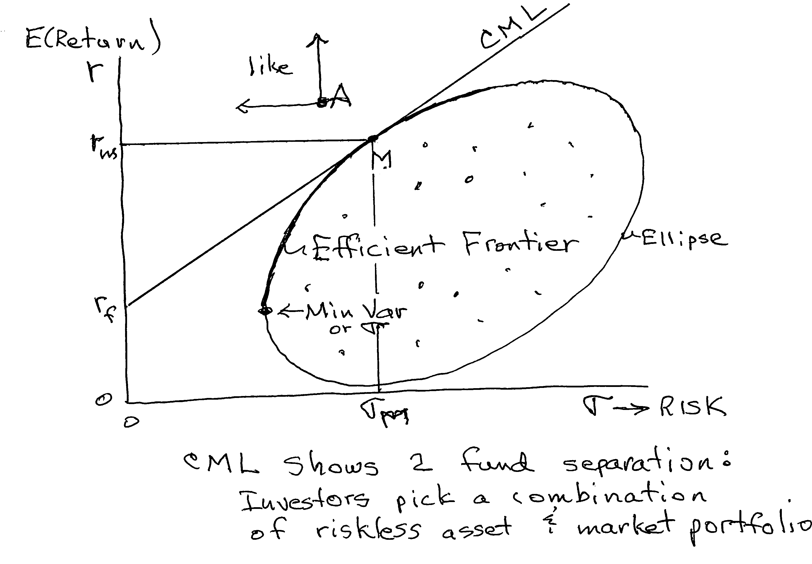

The Market portfolio (M) contains all assets in proportion to their market values.

SECURITY MARKET LINE
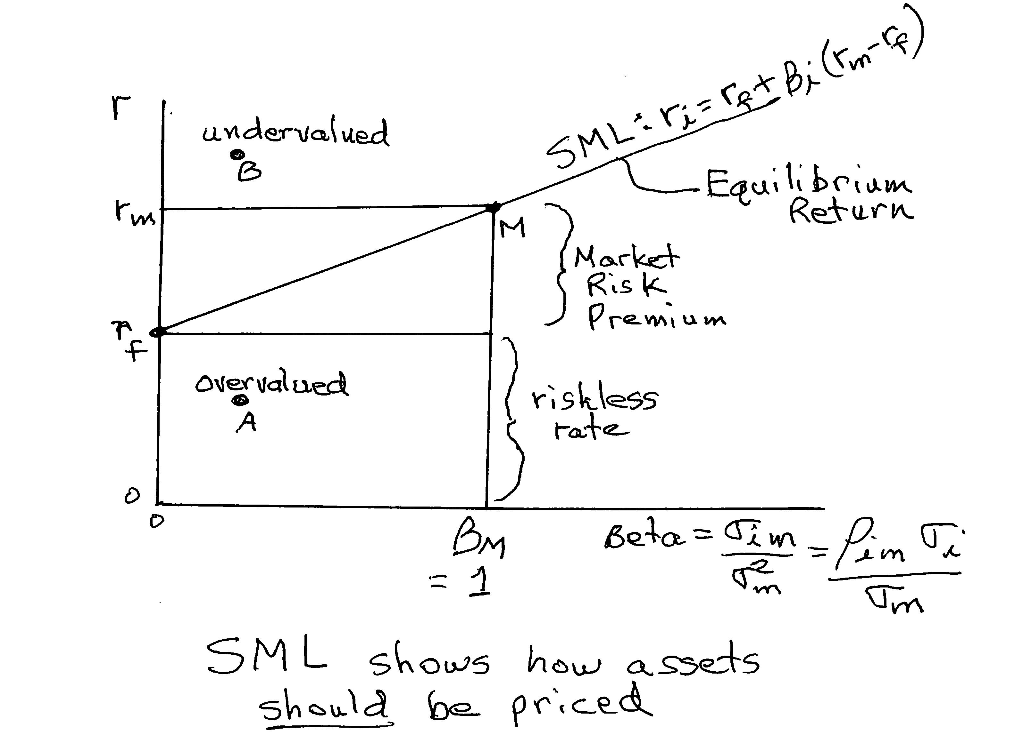

Beta measures systematic, market related, nondiversifiable risk.

