Finance is founded on six principles:

- Money has a time value.
- Higher returns are expected for taking on more risk.
- Diversification of investments can reduce risk.
- Financial markets are efficient in pricing securities.
- Manager and stockholder objectives may differ.
- Reputation matters.

An individual’s reputation reflects his/her ethical behavior which is how an individual treats others legally, fairly, and honestly.

CAPITAL MARKET LINE

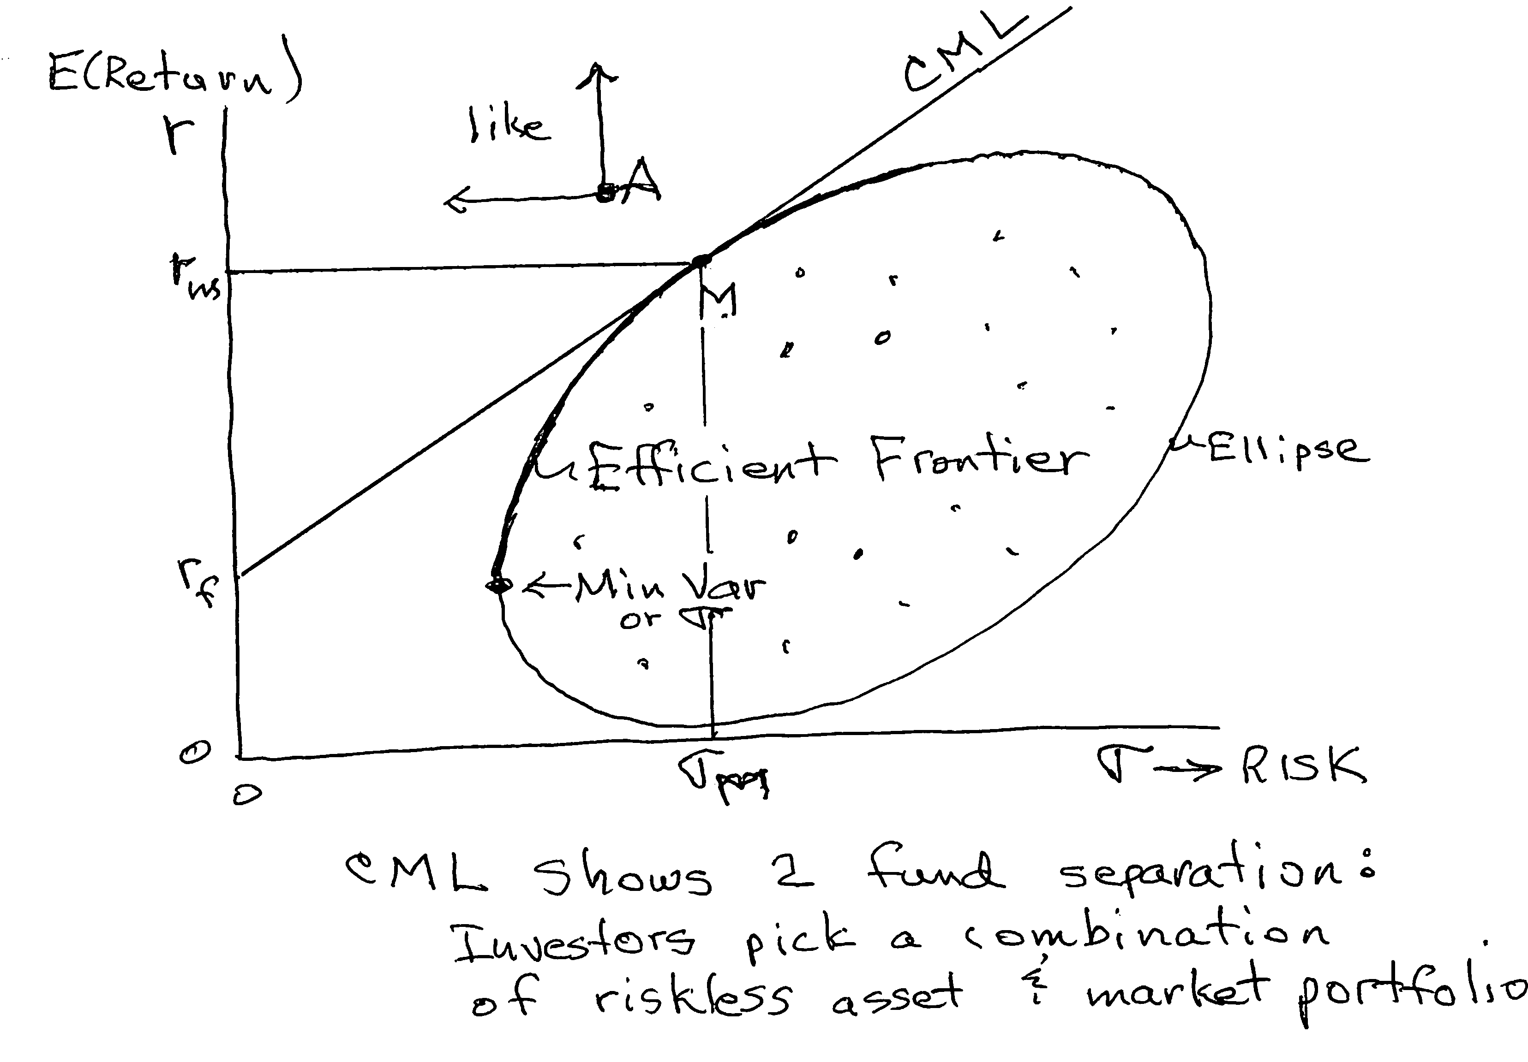

The Market portfolio (M) contains all assets in proportion to their market value.

SECURITY MARKET LINE
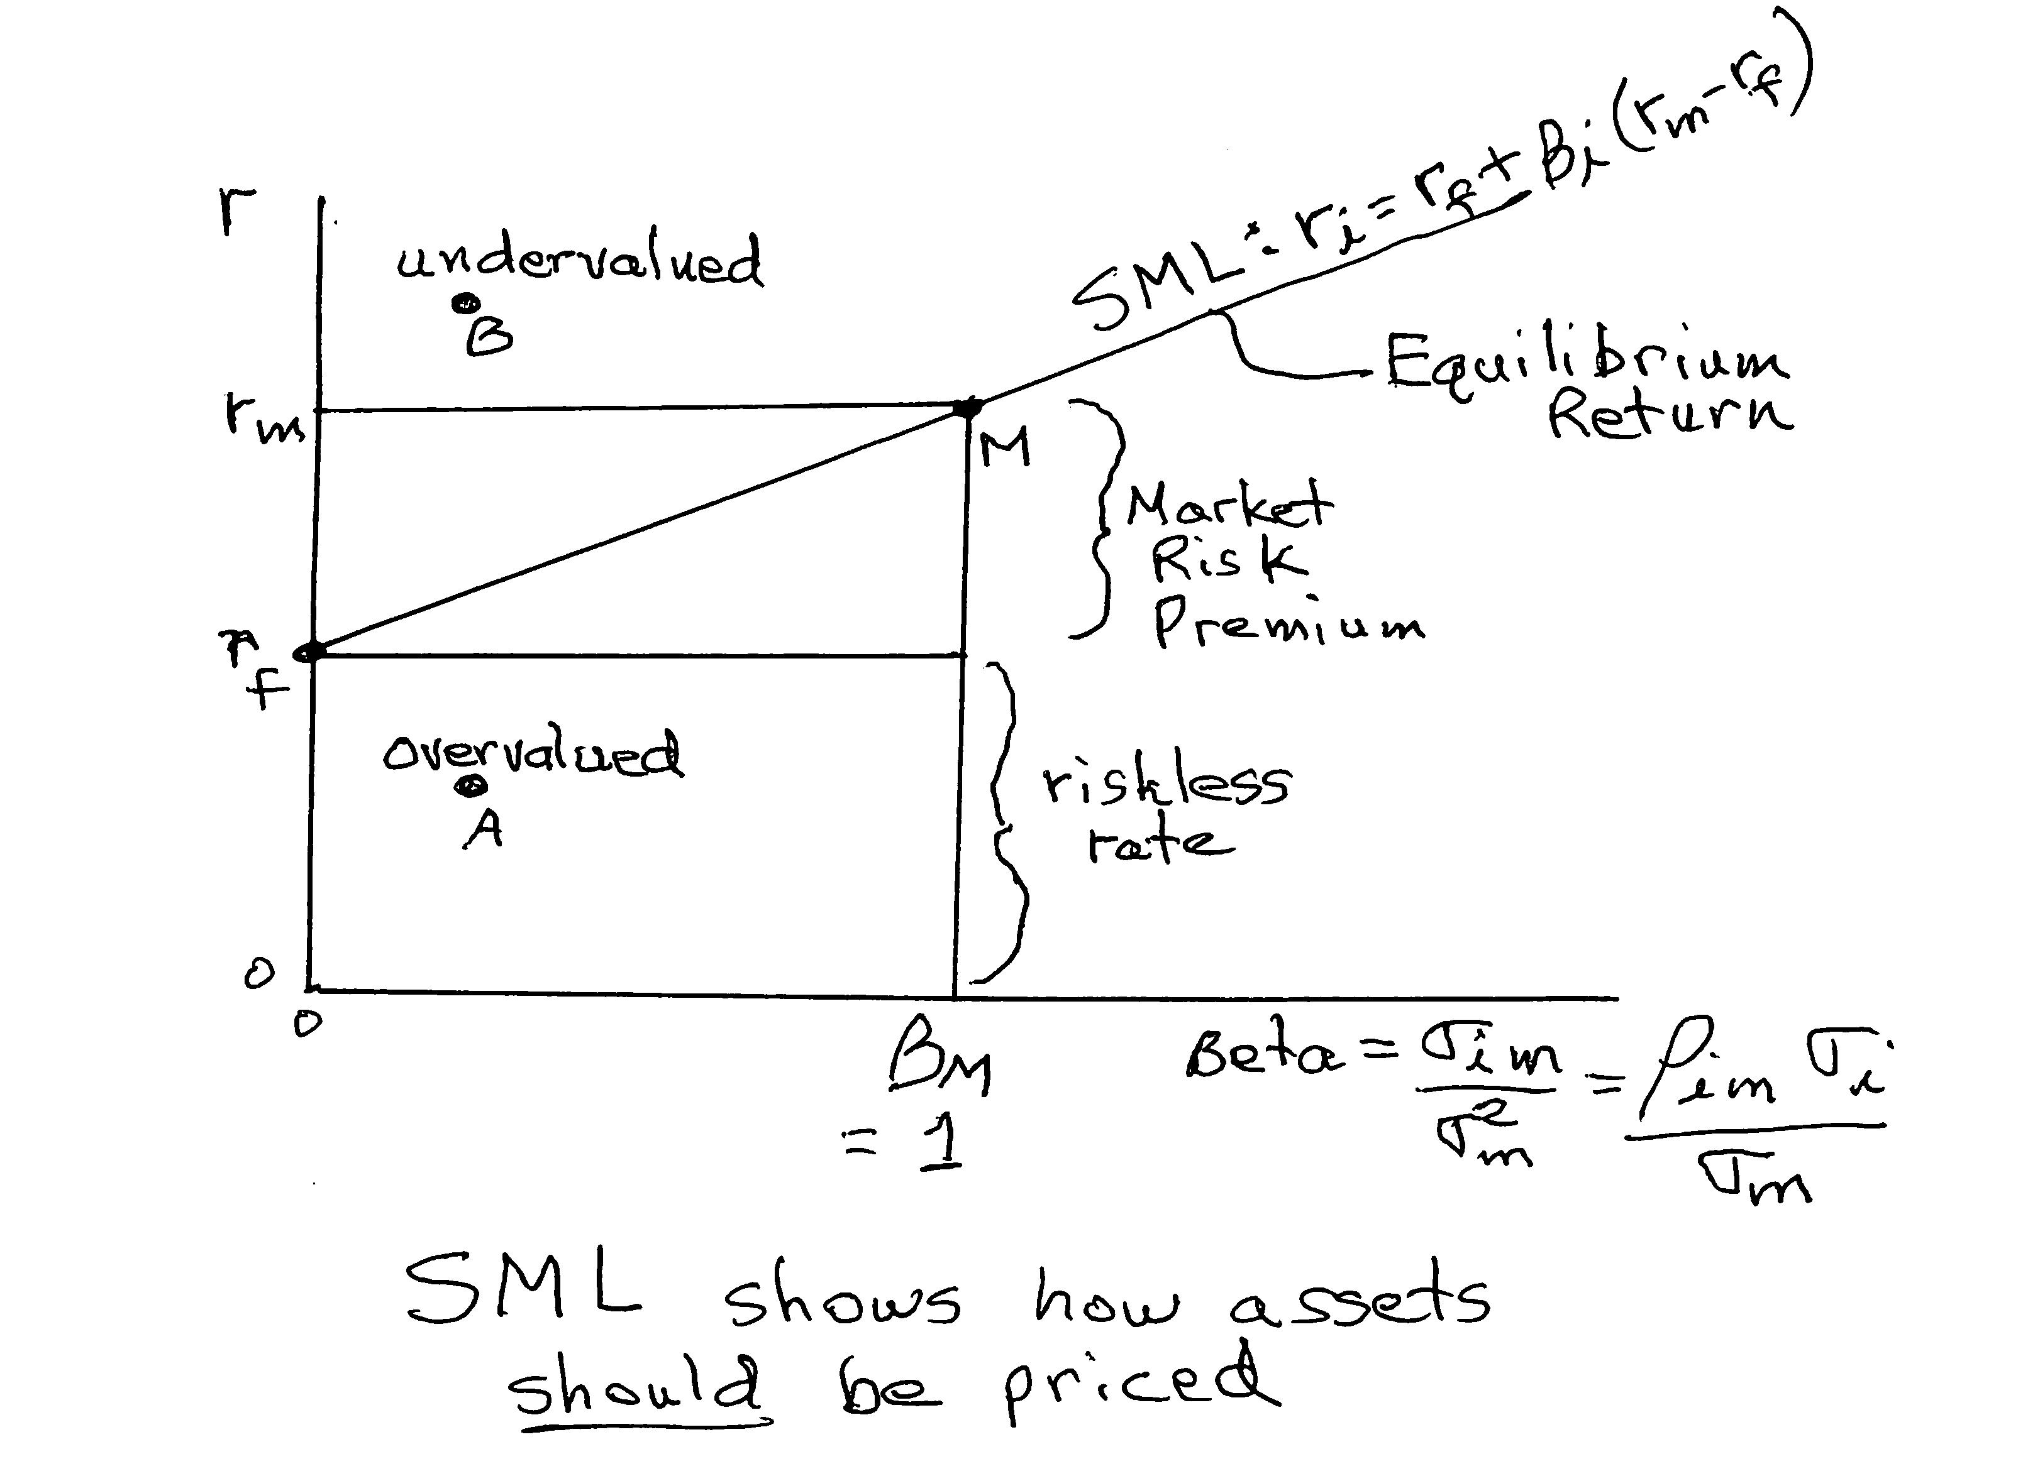

Beta measures systematic, market related, nondiversifiable risk.

