Assignment 3. Financial Calculations and Data Table Models
Overview: Build a workbook to write an Excel user defined function and three unique Data Table examples. The ideas, models and design of this workbook project must be 100% your own and not models used in class. Collaboration with others is prohibited: carefully read the Assignments section of the syllabus. Begin by downloading the Assignment3Starter workbook. Create the PVDGP user defined function then use the three sheets supplied to complete the one-, two-, and three-way data tables described below. Unless otherwise instructed, do not copy anything electronically from another workbook, including your own, the instructor’s, or someone else’s, into the starter workbook.
Begin in the Assignment3Starter.xlsm workbook. Complete the Function sheet by replacing the “????” cells with text or formulas as appropriate. Using the information on the Function sheet, create a User Defined Function to calculate the present value of a growing perpetuity and name it “PVDGP”. The arguments must be in the correct order given on the Function sheet. You will use this function in the two-way table explained below.
Document your function with comments within the VBA Module to accurately explain what the function does and define each input parameter (or argument).
- Construct and explain an example that answers a real-world problem using a one-way Data Table sensitivity analysis. The applied example should be unique and one of your choosing, to include both a model and a Data Table. None of your three data table examples should involve a loan or model like one used in class. The values calculated in the body of the Table (the Table array functions) should cover a 10 by 3 array and reflect different parameter input values. The Table should be on the first sheet named One-Way and contain three output variables (in columns). Use a text box to describe in paragraph form the situation in which your model could be used and what question(s) it answers. Precisely define each variable used in your example. Be sure the documentation is accurate and sufficient to unequivocally explain your example. A typical finance student should easily be able to see how and when to use it with a good understanding of the meaning of the inputs and outputs. Use good programming conventions discussed in class where possible. Documentation and formatting will be a significant part of the grading of this assignment. Use Conditional Formatting to highlight what you consider to be key results in your table. The figure below is an example of a well thought out solution. (Please do not use a similar example or one related to salaries!) Your example should have the same general form as the one below with three panels: left is the model, middle is the data table and a description of the scenario, and right is an explanation of the data table results. Each of the three models in this assignment should be uniquely different examples answering very different real-world questions.
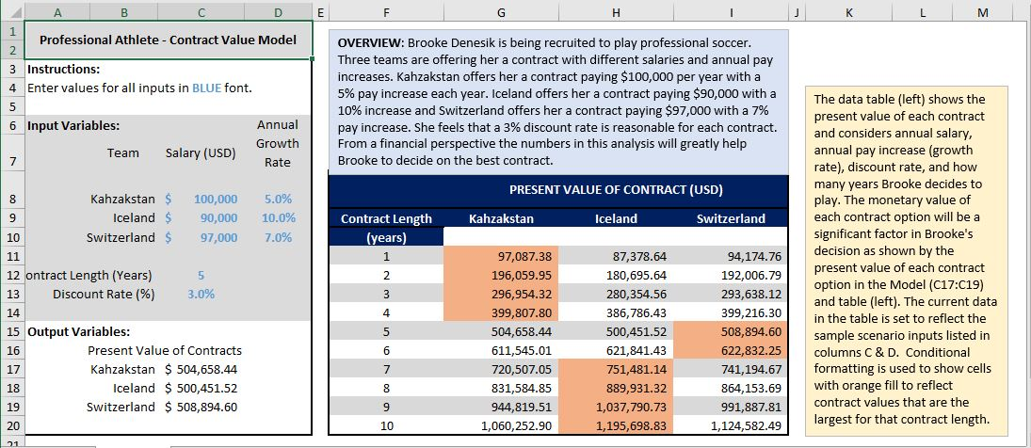

- Build a unique applied model using a two-way Data Table to demonstrate a concept or relationship you studied in a previous course. Incorporate the new PVDGP function as part of the model. It should not involve similar examples used in class so far. The model should help answer someone’s real-world question as in the above example. The Table array function should cover a 10 by 10 array on the second sheet named Two-Way. Use Conditional Formatting to highlight important results in the table. Document/describe/explain the model as discussed above for the One-Way sheet.

- Like the previous question, build a new (not like One-Way and Two-Way sheets) unique applied model using a three-way Data Table to demonstrate a concept or relationship you learned in a previous course. This model should “tell a story” to help answer a practical question. It should not involve the PVDGP function or other similar examples used in class so far. Your example and model should be completely different from your first two. The Data Table array function should cover a 10 by 10 area on the third sheet named Three-Way. Document/describe/explain the model as discussed above for the One-Way sheet and use Conditional Formatting to highlight important table results.

- Be sure to document (label and carefully explain) the models on each sheet and the special function. Use blue font for all input cells (cells whose values the user may change and still produce correct output values). If you have documented the sheets adequately, you should expect any classmate to be able to use and interpret the models. Each of the three tables should use alternate row shading as in the above example.

- When you are done with all previous steps, copy the Certification sheet from your last assignment into the workbook as the last sheet, then complete it with YES/NO answers. Be sure to compress both pictures on that sheet. Just before saving your final version select cell A1 in each sheet, zoom each sheet to 100%, then select cell A1 in the One-Way sheet.

- Be sure that you have named the workbook with your class number and last name (ex. 004James.xlsm). Attach the file to an email with subject field “Assignment 3” to r.ritchey@ttu.edu with a copy to yourself. The assignment is due at 8:00 am on the day given in class. Be careful to send the correct file in one email only. Multiple emails will be penalized. If you must send a corrected file add “2” to the workbook file name after your name (ex. 004James2.xlsm). Do not send the workbook earlier than 24 hours before it is due. Late assignments may be accepted with a significant grade penalty. Grading will reflect how well you followed instructions and completed each task described above and in lecture. Good luck!

- Grading of this assignment will consider:
  - Correct VBA code and documentation for the user-defined function
  - Explanation of each model with description of a real-world scenario and explanation of its practical significance
  - Degree and accuracy of documentation (labeling) of all sheets and functions
  - Uniqueness and complexity of Table examples
  - Accuracy of calculations
  - Formatting of sheets (they should be clear, neat, readable and follow conventions used in class)
  - Use of good grammar free from typographical errors
  - Following submission instructions (one email, correct file name, etc.)

