Assignment 3. Financial Calculations and Data Table Models
Overview: Build a workbook to write an Excel user defined function and three unique Data Table examples. The ideas, models and design of this workbook project must be 100% your own and not models discussed in class. Collaboration with others is prohibited. Begin by downloading the Assignment3Starter workbook. Create the PVGFOA user defined function then use the three sheets supplied to complete the one-, two-, and three-way data tables described below. Unless otherwise instructed, do not copy anything electronically from another workbook, including your own, the instructor’s, or someone else’s, into the starter workbook.
In the Assignment3Starter.xlsm workbook create a User Defined Function to calculate the present value of a growing finite ordinary annuity and name it “PVGFOA”. The arguments must be C, n, g and r (in that order). See Page 19 middle in the Chapter 01.xlsm workbook and the class lecture recordings if you need help with formulas. The function should be capable of computing a value for any reasonable set of inputs, including the special case where r = g. (Hint: If the discount rate is not equal to the growth rate, then the book formula used in class (Chapter 01.xlsm Page 19, middle) works. If not, then you need to supply a different but simple formula to calculate the answer to the function. For help with similar VBA code see the ADDING3 function in the Example Function.xlsm workbook.
Example Function.xlsm shows how to use If-Then-Else in VBA code. Another useful site is: http://www.wikihow.com/Create-a-User-Defined-Function-in-Microsoft-Excel
Document your function with comments within the VBA Module to accurately explain what the function does, the definition of each input parameter (or argument), and what key sections of the VBA code accomplish.
- Construct and explain an example that answers a real-world problem using a one-way Data Table incorporating the new PVGFOA function as part of the model. The applied example should be unique and one of your choosing to include both a model and a Data Table. None of your three data table examples should involve a loan or model like one used in class. The values calculated in the body of the Table (the Table array functions) should cover a 10 by 3 array and reflect different parameter input values. The Table should be on the first sheet named One-Way and contain three output variables (in columns). Use a text box to describe in paragraph form the situation in which your model could be used and what question(s) it answers. Precisely define each variable used in your example. Be sure the documentation is accurate and sufficient to unequivocally explain your example. A typical finance student should easily be able to see how and when to use it with a good understanding of the meaning of the inputs and outputs. Use good programming conventions discussed in class where possible. Documentation and formatting will be a significant part of the grading of this assignment. Use Conditional Formatting to highlight what you consider to be key results in your table. The figure below is an example of a well thought out solution. (Please do not use a similar example or one related to salaries!) Your example should have the same general form as the one below with three panels: left is the model, middle is the data table and a description of the scenario, and right is an explanation of the data table results. Each of the three models in this assignment should be uniquely different examples answering very different real-world questions.
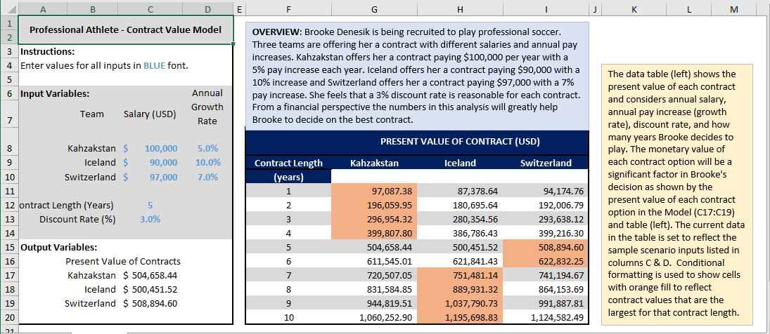

- Build a unique applied model using a two-way Data Table to demonstrate a concept or relationship you studied in a previous course. It should not involve the PVGFOA function or other similar examples used in class so far. The model should help answer someone’s real-world question as in the above example. The Table array function should cover a 10 by 10 array on the second sheet named Two-Way. Use Conditional Formatting to highlight important results in the table. Document/describe/explain the model as discussed above for the One-Way sheet.

- Like the previous question, build a new (not like One-Way and Two-Way) unique applied model using a three-way Data Table to demonstrate a concept or relationship you learned in a previous course. This model should “tell a story” to help answer a practical question. It should not involve the PVGFOA function or other similar examples used in class so far. Your example and model should be completely different from your first two. The Data Table array function should cover a 10 by 10 area on the third sheet named Three-Way. Document/describe/explain the model as discussed above for the One-Way sheet and use Conditional Formatting to highlight important table results.

- Be sure to document (label and carefully explain) the models on each sheet and the special function. Use blue font for all input cells (cells whose values the user may change and still produce correct output values). If you have documented the sheets adequately, you should expect any classmate to be able to use and interpret the models. Each of the three tables should use alternate row shading as in the above example.

- When you are done with all previous steps copy the Certification sheet from your last assignment into the workbook as the last sheet then complete it. Be sure to compress both pictures on that sheet. Just before saving your final version select cell A1 in each sheet, resize each sheet to fit nicely on your monitor, then select cell A1 in the One-Way sheet.

- Be sure that you have named the workbook with your class number and last name (ex. 004James.xlsm). Attach the file to an email with subject field “Assignment 3” to r.ritchey@ttu.edu with a copy to yourself. The assignment is due at 8:00 am on the day given in class. Be careful to send the correct file in one email only. If you must send a corrected file add “2” to the workbook file name after your name (ex. 004James2.xlsm). Do not send the workbook earlier than 24 hours before it is due. Note that late assignments may be accepted with a significant grade penalty. Grading will reflect how well you followed instructions and achieved each task described above and in lecture. Good luck!

- Grading of this assignment will consider:
  - Correct VBA code and documentation for user-defined function
  - Explanation of each model with description of a real-world scenario and explanation of its practical significance
  - Degree and accuracy of documentation (labeling) of all sheets and functions
  - Uniqueness and complexity of Table examples
  - Accuracy of calculations
  - Formatting of sheets (they should be clear, neat, readable and follow conventions discussed in class)
  - Use of good grammar free from typographical errors
  - Following submission instructions (one email, correct file name, etc.)

