Excel assignment: Build a generic loan amortization model
In this assignment you will complete building an Excel workbook to show a table for a fully amortized loan as described in class. Remember that all payments except the last are rounded to the next highest penny. The last payment is rounded to the nearest penny. You will add formulas and formatting as described below. These instructions explain how the completed workbook should look, while you decide on the commands and formulas needed to do the job.
On the Loan sheet in the Assignment2Starter workbook, complete the tasks below changing formulas and format elements as described. As you work on the Loan sheet be sure to enter information ONLY in cells that already contain text or numbers. Do not enter data, text or formulas into cells that originally are empty. Formulas and formatting do not need to be done in the order described below.
Replace the contents of cell A1 with your 3-digit class # and last name. Example: ”245 Baker”.
Reformat cells as needed to show decimals, dollar signs, % and commas like the example figures below. Use the format option with parentheses and red for negative values in the loan amortization table (see cell F11 on the second example below). Show the dollar sign only for appropriate inputs and top of columns containing dollar amounts. The sheet, CustomFormats, shows the five custom number formats you should use to properly format most cells.
Rewrite the Loan Amortization sheet to round the computed payment in B5 to the next highest penny. Use the amount of this payment for all but the last period of the loan. The formula for the last payment should be adjusted to pay off the loan to the nearest penny. Do not round any calculations other than those in the payment cells in B5 and column C.
As in the examples below, format all cells with dollar values so that pennies (decimals) are shown only if the loan principal is less than one million.
Here are two example screenshots with correct formulas and formatting:
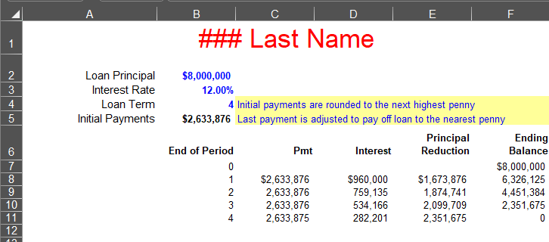
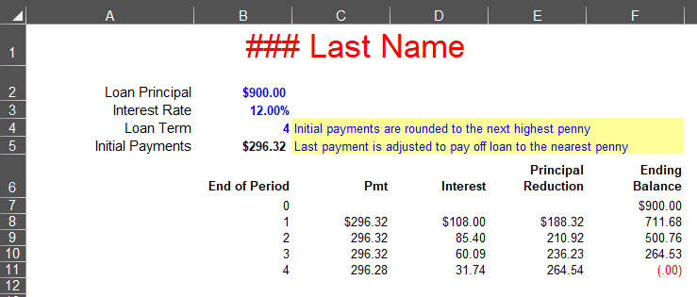

Set up the three blue font input cells to accept only reasonable values and prompt with appropriate messages of your choice. For example, none of the inputs should be negative. Constrain term to a whole number between 1 and 20. For each of the three inputs apply appropriate Settings, Input Message and Error Alert using Data Validation on the Data tab in the Ribbon.
When the workbook is completed, rows beyond the loan term should look blank on your screen. For example, if the term is set to 10 then rows for periods 11-20 should not be visible, i.e., “blanked out”. Devise a way to accomplish this using the IF function with “”, i.e., 2 double quotes – no spaces!!! - for “blanked out” cells. Use the ROW function within an IF function to help calculate the End of Period cell values. There are other ways of accomplishing this, so be sure to use only the above method for displaying “blanked out” cell contents. Do not use conditional formatting to “blank out” rows or use a custom number format (“;;;” or similar) to blank out cells. The above task will carry a high weight in your grade for the assignment.
Set up the workbook so that only the input cells may be selected and changed by the user to produce a completed loan amortization table. All cells containing dollar amounts should show zero decimals if the Loan Principal is $1 million (a 7-figure loan) or more. When finished, be sure to remove any unnecessary conditional formats (only two are needed) and reset the values of the three input cells to the original values in the Starter workbook. When finished, zoom the Loan sheet 100% (neutral/center), select cell B2, then Save the workbook. Remember that your completed Excel model should allow any of the three inputs to change to any (reasonable) amounts.
This and all other assignments are to be completed without help from any other person.
Only after completing ALL the previous steps to the best of your ability, copy from the web then complete the “Certification” sheet as the last sheet in your workbook. Use the drop-down list to answer the two questions. Replace the picture with a recent head and shoulders passport style picture of yourself and a picture of your legal signature. Be sure to provide a picture that would satisfy passport requirements as this element is graded. Be sure that both pictures, yourself, and signature, do not individually exceed 96ppi. You can verify this by selecting each picture in Excel then select Picture Tools / Format / Adjust Group: Compress Pictures using E-mail 96 ppi for size.
Be sure that you have named the workbook with your class number and last name (ex. 004James.xlsx). Attach and email the completed workbook to your instructor: r.ritchey@ttu.edu. It’s also a good idea to copy yourself in this email. Please do not email the file earlier than 24 hours before it is due. Add “FIN 4331 Assignment 2” to the email subject field. Do not send a “Read only” or password protected file. Be especially careful to send the completed workbook as an attached file and not just a link to a file on another device or in the cloud! It is due 8:00 AM on the due day given in class. Note that late assignments may be accepted with a significant grade penalty. Grading will reflect how well you followed instructions and achieved each task described above and in class. Good luck!

