Assignment 2. Build an N-Period Stock Valuation Model
Please follow ALL the instructions below carefully as this is a graded assignment. As with all the other assignments you will turn in for a grade in this course, this is not a group project - you must complete ALL the requirements below on your own without help or assistance from others and without giving help or assistance. You are also responsible for safeguarding your work so that it may not be used by others. If you allow any part of it to be copied by another person both will receive a zero on the assignment and both may be dropped from the course.
These instructions explain how the completed workbook should look and what it should do. You will determine the Excel commands and formulas needed. Clarification of some of the assignment requirements will be discussed in lecture so be sure you are up to date in watching. We assume that you have been presented enough material in class to be able to do a good job on this project with a reasonable amount of thought, patience, and persistence. Your completed workbook should provide the same numeric answers and formats shown in class and in the figures below.
Start with a complete reading of this document. Then open the Asign2Starter.xlsx workbook, then enter your 3-digit class number and last name. Complete the tasks below in the Asign2Starter.xlsx workbook, saving your spreadsheet frequently. Be sure to backup ALL the documents for this class in OneDrive or on a dedicated flash drive in case your computer’s hard drive fails.
On the Stock sheet complete the tasks listed below, changing format elements as described. The completed model should allow users to input the long run dividend growth rate, cost of capital, market price and up to 11 cash dividends. Dividends listed in column B must be values, so if a dividend is projected to be zero, enter zero so the cell is not empty. Dividend cells for periods not forecasted should be empty (see second example below). Note that B3 is NOT an input cell, but rather should contain a formula to indicate how many dividends (0-10) are forecasted and will change automatically with new input data. The formula in F9 (NOT an input cell) should show the correct discount rate.
Replace the “XXXXX” cells with numbers or formulas to complete the model. When complete it should show the computed stock value in A6 and only the table rows for which the user enters cash dividends, up to a maximum of ten projected periods beyond period zero. Do not enter data or formulas into cells other than those initially containing “XXXXX”. Read the red note flags attached to cells for clarification.
If a zero dividend is entered the dividend growth rate next period will be undefined (#DIV/0!). Replace this error if it occurs with the text "N/A" in bolded green. Note that cells that are not “N/A” in C11:C20 should be black not bolded.
Reformat cells in the Stock sheet as needed to show font color, alignment, decimals, dollar signs, % and commas like the example figures below. Remember to format text cells as well. (Row 1 is already correctly formatted). A significant part of your grade will be devoted to how closely your formatting conforms to the examples below. Note that the dollar sign ($) is displayed only at the top of a column and for A6:A8. All cells should be Arial 10 font. The workbook should be saved so that upon opening A1 is visible on all sheets, the Stock sheet is selected and zoom in all sheets is at 100% (neutral).
As in the examples below, format ALL cells that represent dollar values so that pennies (decimals) are shown only if the Stock Value in A6 is less than $10,000. Do not round any calculations in this model. Align and justify (left, center, right) all cells to correspond to the format used in the screen shots below along with font color and bolding.
Set up the workbook so that only the 14 model input cells (blue font) may be selected and changed by the user to produce a completed valuation table. Do NOT use a password to protect the workbook or sheet. Use Data Validation to set up all model input cells to accept only reasonable values and prompt with appropriate input and error alert messages of your choice. For example, none of the dollar inputs (excluding A8) should be negative and the cost of capital should be larger than the long run growth rate. For each of the inputs apply your choice of appropriate “Settings”, “Input Message” and “Error Alert” using “Data Validation”.
Below are screen shots for each of three scenarios, named Stock1, Stock2 and Stock3, showing correct values and formatting. Note that numeric cells and column titles are right justified.
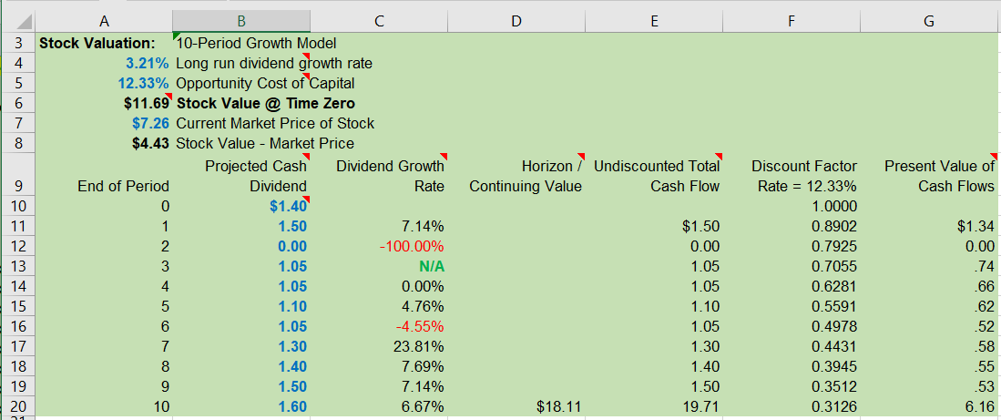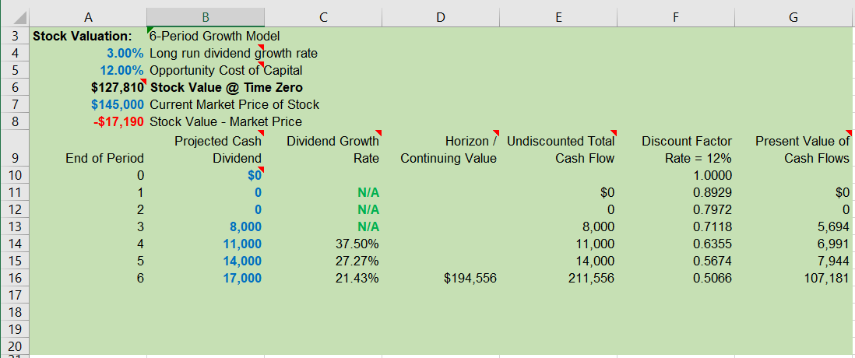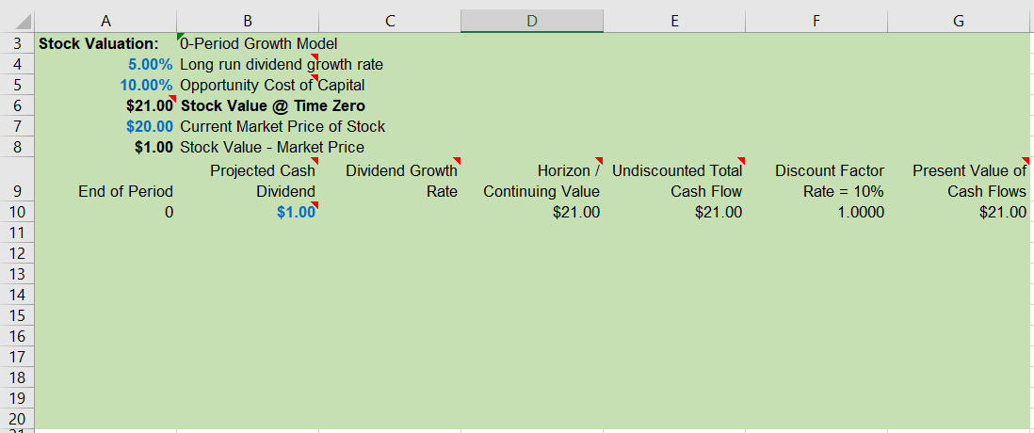
Add these three scenarios to the Stock sheet to correspond exactly to the results in the screenshots above. The completed sheet should show the same results and format shown above and produce correct results if different input values are entered. To help with formatting, five custom number formats to be used in various cells are displayed on the Custom Formats sheet. The format result for positive, negative, zero and text values are shown below each custom number format in rows 4-7.
When the workbook is completed, the rows beyond the last dividend entered should look blank on your screen. For example, if the last dividend entered is in period 5, (B16:B20 are empty), then the rows for periods 6-10 should not be visible. Devise a way to accomplish this using the IF function with “” (two double quotes) in cell formulas to “blank out” cells. As shown in lecture, the double quote will change the cell value and not its format. Do not use conditional formatting or custom number format (;;;) to “blank out” cells. This requirement will carry a large weight in your assignment grade. Conditional formatting may be used for other aspects of the assignment.
Use Solver three separate times to calculate in B23:B25 the cost of equity implied by the market price, one value for each scenario. The three values (numbers, not formulas) should be accurate to at least six significant figures. Note that Solver must be used for each scenario.
When finished there should be no more than three conditional format rules. Reset the values of all input cells to those shown in scenario Stock1. Your completed model should allow a user to change any of the inputs to show the value of their stock. Note that you do not need to research real world stock information in this assignment.
Only after completing ALL the previous steps, to the best of your ability, complete the Certification sheet based on the policy discussed in lecture and the syllabus. Use the drop-down list to answer the two questions. Insert a recent head and shoulders passport style picture of yourself and a picture of your legal signature. Be sure to provide a picture that would satisfy passport requirements as this element is graded. Be sure that both pictures, yourself and signature, do not exceed 96ppi. You can verify this by selecting each picture in Excel then select Picture Tools / Format / Adjust Group: Compress Pictures using E-mail 96 ppi for size.
Be sure that you have named the workbook with your class number and last name (ex. 004James.xlsx). Email it to your instructor with subject field “Assignment 2” - ONE submission please! Note that late assignments may be accepted with a significant grade penalty. Grading will reflect how well you followed instructions and completed each task described above and in lecture. Good luck!

